THE BRUSH-TAILED ROCK WALLABY Factsheet

The brush-tailed rock wallaby is an endangered marsupial of the Granite Belt region.

LOCATION:
It is also found down the NSW coast and into Western Victoria, roughly following the Great Dividing Range.
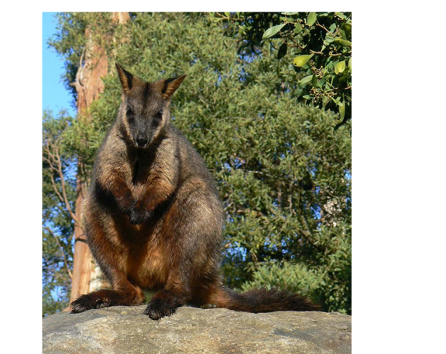
DESCRIPTION:
- long, flexible, bushy tail - bushier towards the tip
- long, thick, brown body fur - reddish brown on the rump, greyer on the shoulders
- white cheek stripe
- black stripe from forehead to back of head
- compact, muscular build
- well padded, rough feet provide excellent traction.
- Average weight of males is 8kg.
- Average weight of females is 6kg.

BEHAVIOUR:
- very agile
- can move swiftly and confidently through rough and rugged areas
- long, flexible tail used for balance
- shelter and bask during the day in crevices and caves
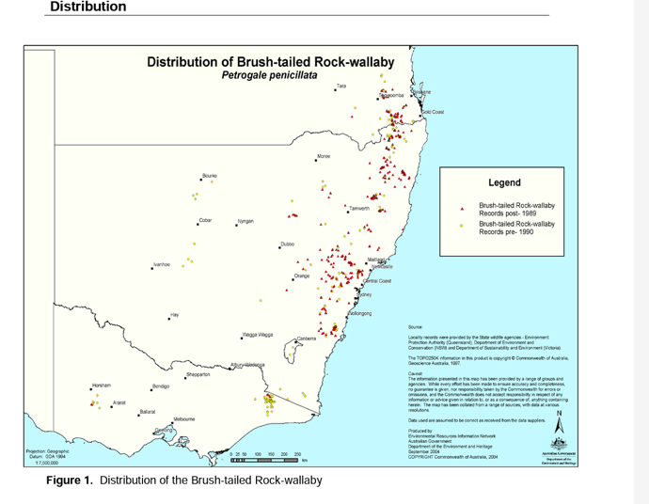
- active at night
- forages for food at night

HABITAT:
- rocky cliffs and slopes, outcrops and ledges
- prefers to live in caves and crevices of high structures.
- highly territorial
- Average home range is approximately3 ha.

FOOD:
- grazes on vegetation in their habitat
- grasses, foliage, bark and fruits of trees and shrubs

BREEDING and YOUNG:
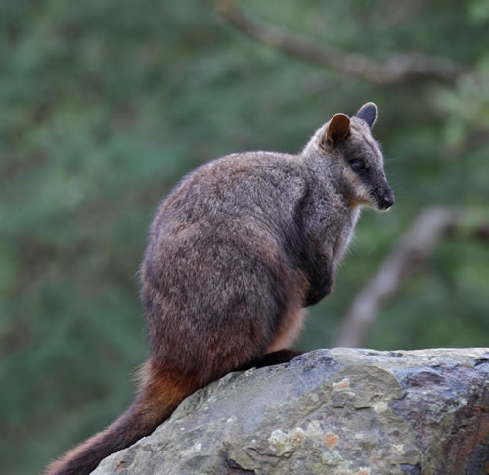
- Dominant male breeds with multiple females
- Breed throughout the year
- Number of births peak between February and May.

THREATS
- Preyed on by foxes, feral cats and wild dogs.
- Compete with feral goats for food and safe places.
- Loss, damage and clearing of habitat.
- Bushfires reduce the amount and diversity food.
- Competition for food and shelter with other wallabies, kangaroos and domestic animals.
- Introduced weeds and plants take over from native plants and grasses.
- Habitats destroyed by feral pigs.
- Killed on roads.

NATIONAL RECOVERY PLAN FOR THE BRUSH-TAILED ROCK-WALLABY

- Avoid further clearing or fragmentation of habitat.
- Control of feral and introduced predators
- Avoid clearing and disturbance around habitats that may give foxes greater access
- Reduce numbers of sheep, goats, other macropods in areas where rock wallabies forage
- Reduction in control of introduced herbivores adjacent to rock-wallaby colonies.
- captive management and release of rock wallabies into designated habitats

ACTIVITIES TO ASSIST THE ROCK WALLABY

- Raise landowners awareness about the presence of Brush-tailed Rock wallabies and provide information for them to assist in their management and protection.
- Retain rocky habitats and nearby open forests or grassland areas.
- Retain habitat corridors between habitats for safe movement through them.
- Protect colony sites from human interference or disturbance.

References:

The Recovery Plan was prepared by Peter Menkhorst and Emily Hynes, Department of Sustainability and Environment, East Melbourne. Published by the Victorian Government Department of Sustainability and Environment (DSE) East Melbourne, November 2011.
https://www.awe.gov.au/sites/default/files/documents/brush-tailed-rock-wallaby.pdf

Other Resources:

https://www.aussieark.org.au/brush-tailed-rock-wallaby/?gclid=Cj0KCQiAutyfBhCMARIsAMgcRJRSlxFoUdJUJ87uyjerTlf116Ags5PqQYtDS03fmUDnU_b_5f1wlYoaArnzEALw_wcB

Aussie Ark Brush-tailed Rock Wallaby
https://www.rockwallaby.org.au/

