Granite Boronia Factsheet

The Granite Boronia is a Commonwealth endangered shrub in the Granite Belt region in Queensland and New England region in NSW. It is considered vulnerable in NSW.
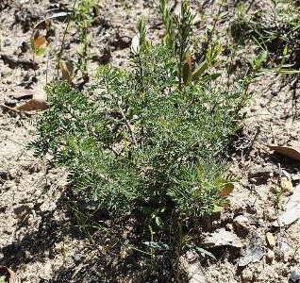
LOCATION:
Granite boronia grows in open forest, woodland and heath on granite soils between Stanthorpe (Qld) and Armidale (NSW).

DESCRIPTION:
Granite Boronia is a medium-sized shrub 0.6 - 2 m tall. Its leaves are divided into nine to eleven leaflets with each leaflet about 2 - 14 mm long and 1 - 2.5 mm wide. When crushed, the leaves have a pungent scent. The leaflets and stems are covered with soft white hairs. Bright pink flowers 6 - 10 mm long appear from July to October.

DISTRIBUTION
- Granite Boronia occurs in scattered localities on the New England Tablelands and Northwest Slopes north from the Armidale area to the Stanthorpe district in southern Queensland.
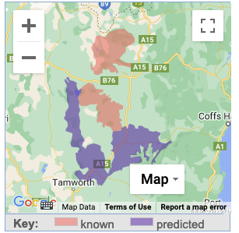
- It can be locally common in appropriate habitat

HABITAT
- Grows on granitic soils amongst rock outcrops, often in rock crevices, and in forests and woodlands on granite scree and shallow soils.
- Important site characteristics include low precipitation and high levels of solar radiation. This semi-arid soil environment will have selected the more xerophytic species from the available regional assemblage of rainforest species.
- The largely barren substrate (e.g., granite) may help to control too frequent fire, thus allowing maturity and seed set.

THREATS
- The small, scattered nature of sub-populations means random events such as wildfire can lead to local extinction.
- Grazing by feral goats and domestic stock.
- Inappropriate fire regime. Risk of population decline with fire intervals less than 5 years or greater than 30 years.
- Clearing of habitat for agriculture or mining.
- Destruction and disturbance of habitat by bush rock collection.
- Trampling of plants by bushwalkers.
- Illegal collection of flowers or seeds by wildflower and horticultural enthusiasts.

National Recovery Plan for the Granite Boronia
https://www.dcceew.gov.au/sites/default/files/documents/b-granitica.pdf

- cessation of feral goat browsing and reduction of goat (and stock) interference
- reduction in feral goat populations in NPWS estate to a minimum
- an improved understanding of the biology and ecology of Granite Boronia to
enable management for long-term viability of the species.
- reserved populations do not suffer any reduction due to human induced causes.
- populations that are not reserved are protected by appropriate measures.
- evidence of seedling establishment and gathering at all or most population areas
- site monitoring to indicate population stability (given natural fluctuations)

ACTIVITIES TO ASSIST THE GRANITE BORONIA
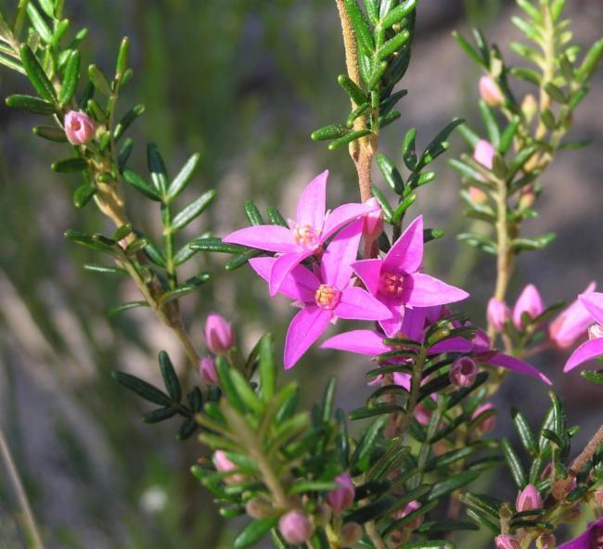
- Retain bush rock in its natural setting and obtain rocks for gardens only from licensed dealers.
- Stay on established walking tracks when visiting national parks and other reserves.
- Enjoy viewing and photographing native wildflowers but leave them in the wild.
- Only buy plants from licensed nurseries.
- Assist with the control of feral goats in habitat areas.
- Manage fire to maintain populations primarily through protection. Liaise with the Office of Environment and Heritage (NSW) concerning appropriate long-term fire management.
- Protect known populations and habitat areas from grazing stock.
- Protect known populations and areas of potential habitat from clearing or disturbance.
- Report any new records to the OEH.

References
https://en.wikipedia.org/wiki/Boronia_granitica

Other Resources
Atlas of Living Australia
https://bie.ala.org.au/species/https://id.biodiversity.org.au/node/apni/2892142#

NSW Office of Heritage and Environment
https://www.environment.nsw.gov.au/threatenedspeciesapp/profile.aspx?id=10098

Australian Government – Department of Climate Change, Energy, the Environment and Water
https://www.dcceew.gov.au/environment/biodiversity/threatened/recovery-plans/national-recovery-plan-boronia-granitica-granite-boronia

