PLATYPUS
https://www.bushheritage.org.au/species/platypus

From top to tail, platypuses (or platypodes) can be 60cm long. Males can weigh 3kg; females 1.7kg.
In colder climates individuals are slightly larger, but they don’t come close to the size of prehistoric platypuses, which were 1m long!
The name Platypus comes from the Greek word for ‘flat-footed’ – they're very awkward on land, walking on their knuckles to protect the webbing of their feet.

Expert swimmers, they use these webbed feet to propel themselves and use their tails to steer through the water. Their dense, silky brown fur is both waterproof and insulating – along with the fat reserves in their tails, their fur allows them to stay warm underwater.
Their ‘duck bill’ is flexible, rubbery and feels like suede. It's often used to dig up food from the riverbed. A Platypus bill is also highly sensitive. Platypuses use electroreceptors on their bills to detect electrical signals given off by prey as it moves.
In other words, with its eyes, ears and nostrils closed, a Platypus can use electroreception to detect movement underwater.
This explains its characteristic side-to-side head movement while hunting. In this way they hunt for prey underwater for 30 to 140 seconds at a time.
The Platypus is one of very few venomous mammals in the world. The spur on the male’s hind foot is connected to a venom-secreting gland. Recent research suggests that the spur is used in aggressive encounters between rival males.
It’s little wonder that 19th Century European scientists found it difficult to believe that the Platypus was real, and fancied this half-beaver, half-bird hybrid to be an elaborate hoax.
Today the Platypus is celebrated as one of Australia’s most unusual and unique animals – it's the state animal of New South Wales and proudly represented Australia in the 2000 Olympics…. as a mascot!
Taxonomically, it's the only species in the family Ornithorhynchidae.

Where do Platypus live?
Platypuses are endemic to (only found in) east and south-eastern Australia. They’re found in freshwater creeks and rivers of Queensland, New South Wales, Victoria, Tasmania and South Australia. They can live in many habitats, from tropical rainforest creeks to streams in alpine areas.
Platypuses are not endangered but the International Union for Conservation of Nature has upgraded their status to 'Near Threatened'. Elusive by nature, there’s a lack of reliable data about where and in what numbers they occur. They’re protected by legislation in all of Australia's eastern states.

How do Platypus behave?
Platypuses are mostly nocturnal. During the day they sleep in the chambers at the end of riverbank burrows. At dusk they emerge to search the river bottom for food, sometimes hunting for 10 to 12 hours a night.
They’re completely carnivorous (meat-eating) and mostly eat invertebrates: swimming beetles and waterbugs, insect larvae, tadpoles, worms, snails and shrimp.
They’re completely carnivorous (meat-eating) and mostly eat invertebrates: swimming beetles and waterbugs, insect larvae, tadpoles, worms, snails and shrimp.
They scoop up gravel and dirt along with their prey, store it in their cheek-pouches, and bring it all to the surface to eat.
Like echidnas, platypuses don’t have teeth. Instead, they use a grinding plate to mash the gravel, soil and food slurry, scooped from the riverbed. They can eat an impressive amount of food in a night – up to 20% of their own body weight!
Females breed at 4 years. After burrowing deep into the riverbank, pregnant females lay one or two eggs. Here, curled up in protective chambers, they incubates their eggs between their tail and rump.
Top of Form
Bean-sized babies emerge from the egg after 10 days and are fed milk for about four months.
Platypuses don’t have nipples; instead milk is secreted through pores and licked off the mother’s skin or fur.
By the time the young are weaned off milk they can swim independently. While largely solitary, Platypuses don’t mind sharing their waterbody with other individuals.
They can live to 12 years old in the wild.

Threats to Platypus
Given their dependence on freshwater systems, habitat destruction and waterway pollution threaten this species.
Water extraction, dams and diversions to water flow have a big impact. Water quality and in-stream habitat (such as submerged logs) are critical so degradation of these elements is a threat.
Run-off from pasture (sediments and nutrient load) can degrade Platypus habitat.
Platypuses are eaten by snakes, water rats, birds of prey and occasionally crocodiles. It’s likely that foxes, dingoes and wild dogs kill Platypuses that venture on land. They were once hunted for their fur – pelts are both warm and waterproof.

What Bush Heritage is doing
Sit quietly by the water at our Liffey Valley, ‘Nameless’ Sylvan or Scottsdale reserves and you might spot this shy species. We look after their habitat by maintaining riparian vegetation (which filters run-off into waterways) and in-stream habitat (e.g. fallen logs, deep pools) and by managing stream-bank erosion.
Canoeists paddling through Black Rock Gorge on a mission to control willows along the upper Murrumbidgee River found this ‘stranded’ juvenile Platypus in a sinkhole on the bedrock platform of the falls. Unable to climb out, the little platy was swimming ‘round and round’ in the sinkhole and by the bedraggled looks of it, maybe had been there for a while!
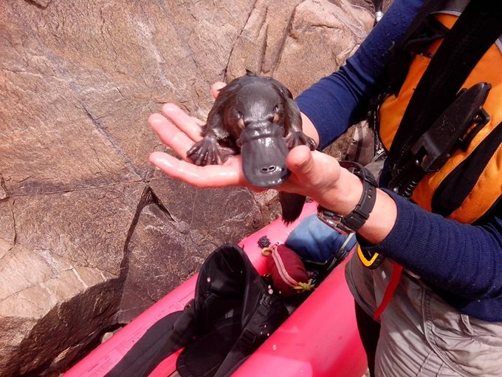A baby Platypus rescued from a a sinkhole on the Upper Murrumbidgee River. Photo Richard Swain.
Upon being hauled up, the little platy rested, exhausted in the rescuer’s hands … but to our delight … after about 5 minutes started to preen itself. Twenty minutes later, its fur fluffed up like a mink coat on parade, our platy friend was larking about amongst the rocks near the edge of a nearby pool where it had been placed - oblivious that we were watching!
The Granite Belt is a region located in Queensland, Australia, and the platypus is considered vulnerable across its entire range, including the Granite Belt.
The platypus is listed as "Vulnerable" under the International Union for Conservation of Nature (IUCN) Red List of Threatened Species, which means that it is facing a high risk of extinction in the wild. Habitat loss, degradation, and fragmentation, as well as pollution, predation, and climate change, are some of the major threats to the platypus population.
In the Granite Belt, the platypus may face additional threats from agricultural activities, urban development, and recreational activities that can impact their habitat and water quality. Therefore, it is important to protect and conserve the platypus population in the Granite Belt and its entire range to ensure their survival in the wild.

Black Rock Gorge is a little travelled, pristine and (to say the least) highly scenic section of the upper Murrumbidgee River … part of which forms the Scottsdale Reserve boundary. This part of the river is also the home of several nationally listed threatened fish species.
Bush Heritage at Scottsdale is a key partner of the Upper Murrumbidgee Demonstration Reach (UMDR).
Donate today to help us continue this and other vital conservation work. Most of our operating costs are funded by generous individuals. Donations over $2 are tax-deductible and we can't thank you enough for your support.
DONATE TO KEEP NATIVE SPECIES THRIVING
- Stories about native species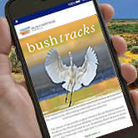
EMAIL NEWS
- Protect the homes of our native species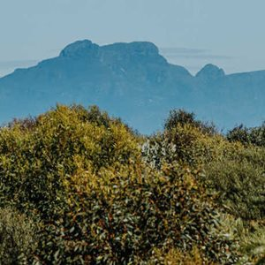
DONATE NOW

Platypus stories
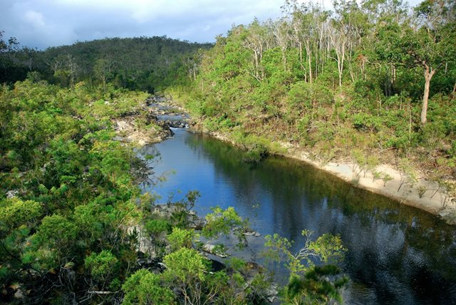
01 Sep 2022BLOG POST

Platypus spotted on Yourka Reserve!
We recently found a Platypus in Cameron creek - the first record of the species on Yourka Reserve. It's a sign of good river health and hopefully, there are more sightings to come.
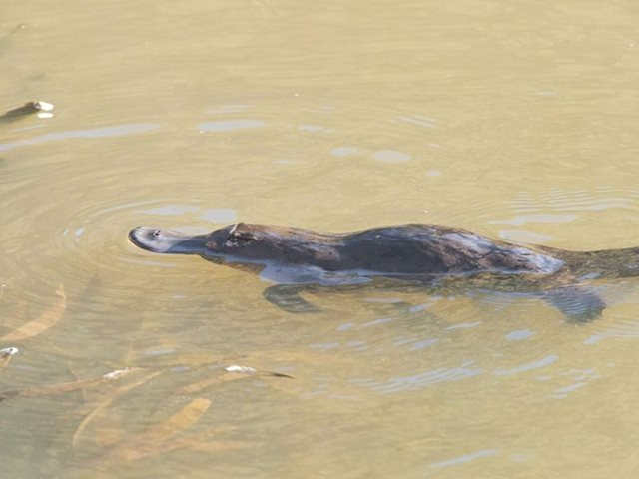
03 Sep 2019BLOG POST

A special moment in time
It was a beautiful afternoon settling into my position on the bank of the great Murrumbidgee River to be part of the annual Platypus and Water Rat survey on Scottsdale Reserve in New South Wales.
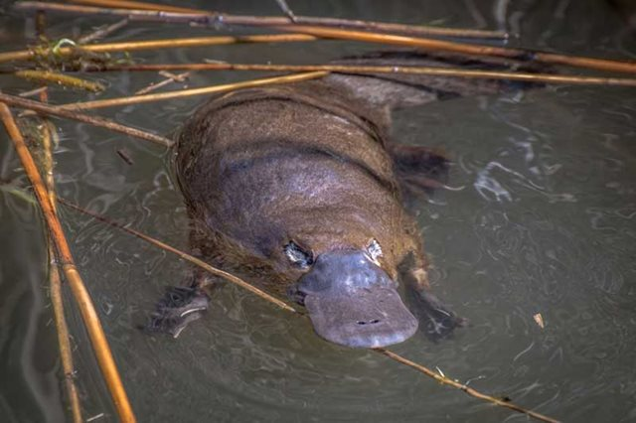
11 Dec 2018

Platypus patrol
A group of dedicated volunteers is helping to shed light on Platypus populations in the upper Murrumbidgee River.
Error! Filename not specified.
28 Sep 2018BLOG POST

Platypus watched at Scottsdale
An extra hardy bunch of volunteers braved temperatures as low as -8 degrees to survey Platypus at Scottsdale Reserve during August! Though our volunteers were not disappointed, sightings were down this year and Platypus seemed more wary and shy.
Error! Filename not specified.
12 Sep 2017BLOG POST

Murrumbidgee Platypus surveys
In the last week of August 10 volunteers conducted the annual platypus survey on the Upper Murrumbidgee River at Scottsdale Reserve, in association with Cooma Waterwatch coordinator, Antia Brademan and Reserve Manger, Phil Palmer.
Error! Filename not specified.
14 Mar 2017

A different lens
The sun is just rising over Scottsdale Reserve as Richard Taylor quietly slips from the sleeping quarters. The chill in the air reminds him of his native Lancashire in north-west England, although the landscape is vastly different. With him are his trusty camera and a collection of lenses.
Error! Filename not specified.
06 Dec 2016

Scottsdale’s loveable larrikin
Chilly temperatures can’t deter a small group of Bush Heritage volunteers from getting to know one of one of Australia’s most iconic species – the Platypus – a little bit better.
Error! Filename not specified.
22 Oct 2016BLOG POST

Volunteers in huge Platypus surveys!
We're not talking about surveying a huge Platypus, but about the huge effort Bush Heritage volunteers and Scottsdale Reserve Manager Phil Palmer have put in to support the Upper Murrumbidgee Waterwatch Platypus surveys this year!
Next

More species

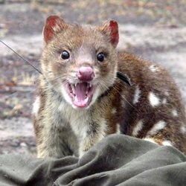
Quolls

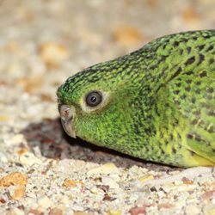
Night Parrot

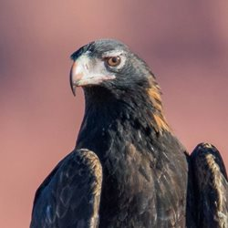
Wedge-tailed Eagles

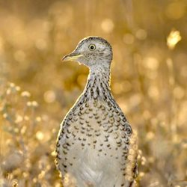
Plains-Wanderer

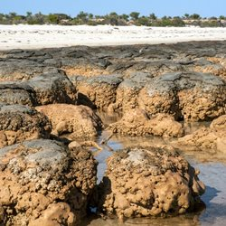
Stromatolites

