Wallangarra white gum Factsheet

The Wallangarra White Gum is a vulnerable plant in the Granite Belt region and an endangered plant northern NSW.

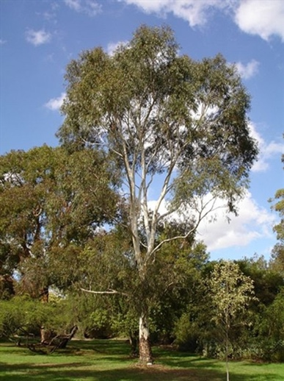
LOCATION:
This medium-sized Australian native tree originates from the elevated areas of the Wallangarra area in northern New South Wales and southern Queensland.

DESCRIPTION:
A small tree to 15 m tall with smooth, powdery white to pale grey bark. The adult leaves are shiny green, 10 - 15 cm long and 6 - 10 mm wide. The flower buds are oval-shaped with a conical cap, and the small gumnuts are oval-shaped, 4-5 mm long and wide. This canopy is often open and pendulous.

DISTRIBUTION
- It is known to exist in only three locations in NSW near Tenterfield including Bald Rock National Park.
- In Queensland, it is equally rare occurring at three sites on the Granite Belt including one population in Girraween National Park.
- Only one Queensland population has more than a dozen trees.
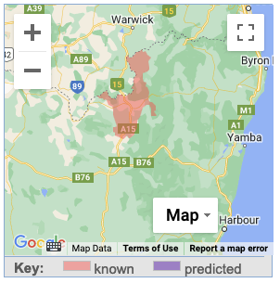

HABITAT
- Open eucalypt forest, woodland and heath
- Well drained granite hilltops, slopes and rocky outcrops
- Typically found in high altitudes
- At lower elevations, can occur in less rocky soils in damp situations.
- The exact location of the sites is restricted information due to the sensitive nature of either the species or the site.

THREATS
- Clearing and fragmentation of open forest and woodland habitat for agriculture and development.
- The small size of most populations increases the risk of local population loss from random events and may reduce genetic diversity and species fitness.
- Lack of knowledge of the key threats to the species.
- Damage to seedlings plants by bushwalkers going off tracks in the species' habitat.
- Timber collection.
- The impact of fire on the species is unknown, however if mature trees are killed by high intensity fires, it may take significant time to re-establish a viable population.
- Feral browsers and livestock browsing on or trampling saplings.
- Illegal seed collection for horticulture.
- Populations are small and fragmented.
- Lack of information on the distribution/extent/population size of the species.

National Recovery Plan for the Wallangarra White Gum

- This species has been assigned to the Site-managed species management stream under the Saving our Species (SoS) program.
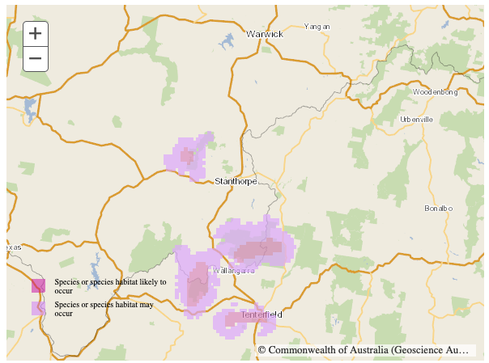
- The SOS strategy aims to secure the species in the wild for 100 years (to save it from extinction) and maintain its conservation status under the Act.

ACTIVITIES TO ASSIST THE WALLANGARRA WHITE GUM

- Support local Landcare groups protect known populations and identify new sites.
- Stay on established tracks when visiting national parks.
- Protect known populations and areas of potential habitat from clearing and timber collection.
- Rehabilitate and protect disturbed areas of habitat.
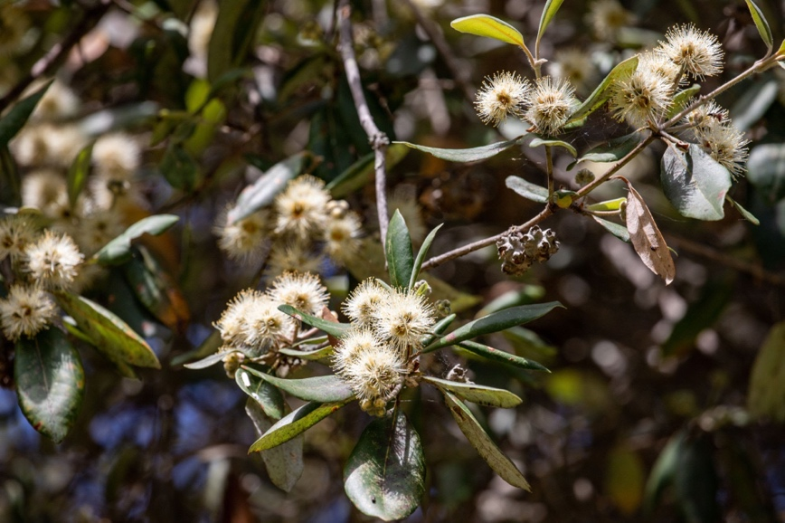
- Notify the Office of Environment and Heritage of any new records of trees in NSW.
- Undertake surveys for new populations.
- Only buy specimens from licenced growers.
- Undertake research into the ecological requirements, fire ecology and threats to the species.
- Ensure existing seed bank is maintained.

References
There is no adopted or made Recovery Plan for this tree.
http://www.environment.gov.au/cgi-bin/sprat/public/publicspecies.pl?taxon_id=9640

https://en.wikipedia.org/wiki/Eucalyptus_scoparia

Other Resources
NSW Office of Heritage and Environment
https://www.environment.nsw.gov.au/threatenedspeciesapp/profile.aspx?id=10315

Australian Government – Department of Climate Change, Energy, the Environment and Water
http://www.environment.gov.au/cgi-bin/sprat/public/publicspecies.pl?taxon_id=9640

