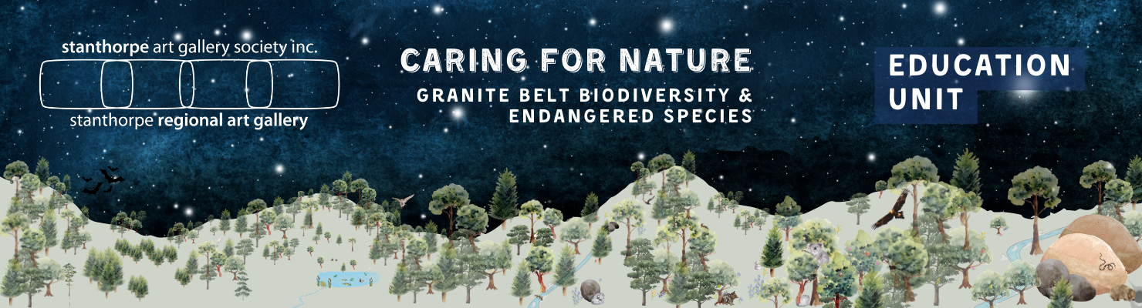

YEAR 2

UNIT SUMMARY

ENGLISH: text structure and organisation - Information texts; Fact and Opinion; purpose, language features of texts. Note: There are many text types you could focus upon, however informative texts best suit the content and learning within the unit.

SCIENCE: Biology: Patterns and Relationships in habitats; using scientific knowledge to make predictions; Introducing Biodiversity

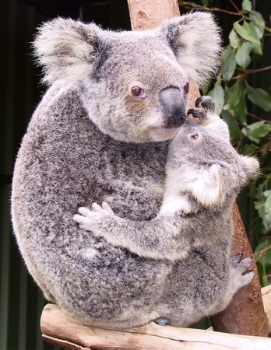
HASS: Geography: Atlas - locations and connections between places in Australia; mapping of local area. Girraween National Park.
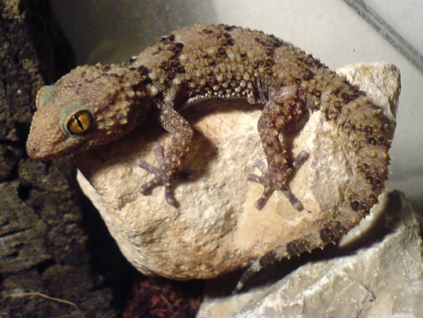
Border thick-tailed gecko
ART: 2D works of art based on the themes of biodiversity, endangered animals of the Granite Belt for the Crisps” Art Show

ASSESSMENT: Some activities in the unit have been considered as possible assessment tasks. A generic rubric has been created to cover the main CDs.

Note: Throughout the planning, “endangered” refers to vulnerable and endangered species of the granite belt. Lists of both are available here (animals) and here (plants).
Koala & joey

Subject/Content Descriptions | Teaching and Learning | Resources and Vocabulary | Notes

ENGLISH
Language: Text Structure and organisation  Students identify how texts across the curriculum are organised differently and use language features depending on purposes  AC9E2LA03 | Learning Focus 1  We are learning about the purpose of text types.  Beginning with a familiar picture book and an age-appropriate chapter book, discuss the difference in language, presentation and other features. Talk about the audience - who has each been written for? How can you tell?  Drawing upon prior knowledge, compare an age-appropriate information book with the chapter book. What is the same? What is different? Could the audience be the same for each? So why are they written and presented differently - different purpose.  More specifically, compare the introduction of the narrative book with the intro of the information book. Depending on book choice, there will be lots of differences because their purpose is different.  Using the PowerPoint: Purposes of Text Types, children identify, with support, language features and the presentations of other text types, which work together to meet the purpose of the text type.  For example, compare a sign and a poster (that provide information. Ideally choose something related to native animals). How are the language features/presentation different? For example, the sign may display a picture/symbol only, from which we get the message. The poster may have lots of information, set out in small amounts as well as a lot of colours, photographs etc. They are different because the purpose is different. The sign’s purpose may be to warn, get your attention or give 1 piece of information only. The purpose of the poster is providing more information by including, text, photographs, tables, text boxes. The sign gives the reader immediate information. Information on a poster can be read slowly, you can skip the parts you are not wanting to know about, you can put the poster on the wall and come back to it whenever you  Want.  Learning Activity  Using a table or other graphic organiser, students work in pairs or Learning Teams to record the purpose of the text types reviewed. This activity could also be a whole class task. An example ...  Text Type Purpose  Picture Books Fiction To entertain, to be enjoyed.  Information Book about Worms To give information in chapters about worms using text, headings, photographs and more  Koalas Cross Here Sign Informative To warn, to inform,  Recipe for Chocolate Crackles Procedure To inform, to provide the information in a particular order, needed to do the task  What we did on the Weekend Recount To inform, to share experiences, may have opinions, personal.  Poster about Blue Tongue Lizards Informative To give information as a large, colourful, interesting display that can be put on the wall and read whenever you want. | Provide student access to a variety of texts which may include posters, brochures, maps, fiction and information books.  Vocabulary:  Purpose, language, narrative, brochure, sign, map, poster, inform, information, informative, text type,  Change text types mentioned here to any that are more appropriate or relevant to the learning in your classroom.  PowerPoint: The Purpose of Text Types covers signs, maps, brochures, posters  Add/remove information in the PowerPoint to suit your lessons. | Prep and Year One units have Learning Activities that identify and describe Fiction and Information Texts  Utilise them first if your class requires a refresher.
 | Learning Focus 2  We are learning about the difference between a fact and an opinion.  As a class, discuss the differences between fact and opinion, with examples from the students. Write up some of these examples on the board and look at the language used. Words like “I think....”, “I like .......” “I believe....” “I feel....” “etc.” tell us that someone is giving an opinion.  - Is the opinion always true?  - Can you look in a book to see if is true that vanilla ice-cream is the best?  Facts can be researched to see if they are true, to prove them.  Opinions are thoughts or ideas or feeling people have about something.  Follow up with a Youtube video on the topic. | https://www.youtube.com/watch?v=DwdDClWP6i4  Fact or Opinion for Kids Less than 3m  https://www.youtube.com/watch?v=PE_TPYdCssA  Fact and Opinion for kids More than 7mins but more detailed.  Play some fact or opinion games  https://www.youtube.com/watch?v=emDQia_wH8o  Fact or Opinion Game 3.07m This game can be adapted and replayed in the classroom.  Teach Starter and Twinkl have some if you are a subscriber.  TeachersPayTeachers is another good source. | It may be desirable to move this activity to the beginning of the unit if the knowledge is required when looking at purpose of text ty  At this point you could also introduce or revisit persuasive text as it appears in text types such as advertisements, posters, etc.
Learning Focus 3
We are learning that, because of their purpose, some texts use both facts and opinions.

Advertisements will give some facts about a product as well as an opinion. Some brochures and posters will also have both.
Share some examples, or students can look for examples from home, in magazines etc. and bring them in.

Why do some text types have facts and opinions - look at their PURPOSE which will be to convince you to like something, or to buy something. The creators of the text type want you to agree with their opinion so that you ill spend your money on their product or service.

This is not a bad thing, but we need to be able to understand the difference between fact and opinion so that we make the right decisions.

Discuss, create and act out some scenarios

SCIENCE
Science Inquiry: Questioning and Predicting  Students pose questions to explore observed simple patterns and relationships and make predictions based on experiences.  AC9S2I01 | Learning Focus 1  We want to find out why animals live places in our local area and what are their relationships with the plants, features and other animals in this area.  Discuss local wildlife and where we find it.  Model first, then children pose Who, What, When, Where and Why, How questions to a student who has observed native wildlife somewhere locally.  What have you seen? Where was it? What was it doing? What was the weather like? Why was it there? How did it move? How did you feel when you saw it? etc.  Use notetaking strategy on the board (e.g.dot points) to record the answers from some of the students and look for the facts, patterns, relationships we might be able to discover about this animal.  For example  Would we need to do more research before we can be sure about fact X?  This animal was seen during summer. What could that tell us?  This bird was seen on the banks of the creek. Why? Is there a relationship between the creek and the bird?  The snake was spotted near the hen house. Why?  Learning Activity 1  Tell the students that we are looking for patterns and relationships (or connections) between an animal in our local area and everything in its habitat.  Model the scenario of the kangaroos on the golf course - we need to find out why they like to be there?  Students share their predictions. For example ...  - They like to eat what is there (so we need to find out what kangaroos like to eat, to see if this is true.  - There are a couple of small dams for water. (relationship or connection- the kangaroos need those dams).  - What about shelter and protection? We need to find out what kangaroos use for that.  - What else do kangaroos need (open spaces because they live in groups).  Is the golf course the best habitat for the kangaroos?  Do they need to have a relationship with people? What does that look like? How would it work?  Model a web of the relationships between the kangaroos and their golf course habitat. (See example)  Together make a list of other wild native birds and animals whose habitats are in the local area.  Suggestions:  Cockatoos live in trees near the creek but travel all over Stanthorpe.  Blue tongue lizards - in gardens and yards.  Flying foxes live in trees near the creek.  Wild ducks are found on quart pot creek.  Turtles - in the creek but also in other parts of the local area.  Students will also have examples.  Students choose one animal from the list and make predictions about the patterns and relationships it might form in its local habitat. They ask questions, use prior knowledge, or research to check their predictions  Have the students create a web of patterns and relationships that present the biodiversity within the scenario they have chosen. They may draw features. They may work individually, in pairs or in Learning Teams,  and reproduce some of these in their workbooks.  Possible Assessment Piece | https://www.worldanimalprotection.org.au/  Animal facts and excellent free animal activities that can be downloaded. Limited Australian wildlife.  https://www.wilderness.org.au/protecting-nature/endangered-animals-and-plants/10-endangered-australian-animals?gclid=Cj0KCQiA_P6dBhD1ARIsAAGI7HDGF33ibVNOyNdU10Bo1E03cb2XIqPuL9IO1Rfs9xrSEUCE0vMZPQ0aAtMAEALw_wcB  10 endangered animals in need of urgent help. Includes koala and greater glider  Invite a member of the Stanthorpe Golf Club to talk about wildlife on the course. Students pose and prepare questions to ask, such as  - Are any of the animals, birds, reptiles a problem? Why?  - How do you deal with the problems?  - How do the people and the animals safely share the course?  Vocabulary: habitat; location; shelter; needs; predict; prediction; protect; feature; sketch. | You may need to revisit or teach  - open ended questions  - the 5 Ws and an H strategy  - making predictions  * Some clever students may reason that kangaroos were there before the golf course, and their natural habitat was removed. A great topic for discussion.
Students describe how people use science in their daily lives, including using patterns to make scientific predictions  AC9S2H01 | Learning Focus 2  We are using scientific knowledge to make predictions.  Question: What do you think will happen to the kangaroos on the golf course if we have a long drought?  Prediction:  Children in Learning Teams write down their prediction.  Come together as a class a to share and discuss.  Which predictions are based on science?  Which prediction is the most likely answer? Why?  Question:  What do you think will happen to the flying foxes if they are moved on? Why?  Prediction:  Have the students pose some questions for which a prediction, based on Science, may be made  Lead the students to understand that when natural disasters occur the animals’ needs are not being met anymore. There is no home or no water. The animals’ relationships within that habitat are being destroyed.  Introduce the term Biodiversity. It is every living thing in one place living in relationship. If all the living things are present and working well then, we can see that in the patterns and relationships. If some living things there are sick or endangered, biodiversity may be out of balance, or it may change, and we see that in the connections in that habitat.  Discuss what happens to animals when we cut downs trees, build homes, roads, etc.  Biodiversity is affected. Many patterns and relationships are broken. The habitats now do not have all the things necessary for the animals to survive. They must move on, find somewhere else if they can or they will not survive.  They may even become endangered.  You may want to leave it there or follow up with Picture and Information Books about Endangered Australian Wildlife. The children may also provide a new path the explore. | Jackie French’s picture books Fire, Flood, Drought, Plague and The Fire Wombat are recommended resources.  Vocabulary: Biodiversity, systems, endangered, natural disaster, pollution  Definition: Biodiversity is a term used to describe the full mix of life on Earth. From the tiniest insects to the tallest trees—and everything in between. It even includes us—human beings—though we tend to forget we are part of the natural world.  Biodiversity is the foundation of the natural systems that produce clean air, drinkable water, a healthy climate, medicines, and food. Biodiversity also serves as a natural barrier against many diseases, including diseases that can turn into pandemics. International Fund for Animal Welfare 2022  https://www.wilderness.org.au/protecting-nature/biodiversity-and-extinction  Quick video explaining biodiversity in terms of Australian wildlife  Biodiversity - take this as far as you want to, but at this stage, introducing the term with an example of is sufficient.  Some examples:  If the creek becomes polluted and choked by rubbish, predict how this might affect the biodiversity of the creek habitat?  If a bush habitat is experiencing a long drought, how might this affect the animals and plants? What will happen to the biodiversity of this habitat? | If at any time students comment unfavourably on, for example, the noisy presence of the flying foxes, it presents a great opportunity to launch into fact and opinion and to expand the discussion and research to develop understanding of both sides of the issue.  This lesson links closely to focus on Girraween Park in Geography

HASS Sub-strand GEOGRAPHY
Students identify how places can be spatially represented in geographical divisions from local to regional to state /territory and how people and places are interconnected across those scales  AC9HS2K03 | Learning Focus 1  We are learning about the purpose of Atlases  Using an age-appropriate atlas (class set if possible) allow the students to browse through, looking for something they already know and something they would like to learn about. Use their responses as an introductory lesson on this information text.  Other questions for discussion  What is the purpose of an Atlas?  Who is the audience of this particular Atlas?  What text types does the Atlas use to present information? (maps, text boxes, photographs, etc) Look for examples. Spend as much time and as many lessons as required for the children to become familiar with the Atlas. | Resources:  Class set of atlases, if possible. Otherwise, a large map of Australia, showing states and capital cities, that can be view on the whiteboard  If you are a subscriber, Teach Starter has a good worksheet activity on Australian States and Capital Cities,  https://www.youtube.com/watch?v=RM0X6IIHenI  The map of Australia, with oceans and states is drawn. Children can see if they know the name of the state before it is written. | Talk about and use other kinds of maps and other places where maps are found  - the ones we make ourselves, treasure map, maps on the sat navs in our cars, maps of towns, maps in travel brochures, Google maps etc.
 | Learning Focus 2  We are using maps to learn about Australian States and capital cities and our own location, Stanthorpe.  Focusing on the map of Australia and its geographical divisions, firstly locate Stanthorpe together and encourage children to ask questions about the location. Establish some facts e.g. Stanthorpe is  - Close to the NSW border (some students might even live in NSW)  - Not on the coast  - Inland from Brisbane  - South of Toowoomba and Warwick.  Share what we all know about the different states of Australia. For example, some of the students may have come from another state, have family elsewhere or have gone on holiday to Sydney and seen the Opera House. During the sharing everyone finds that state/city/region on the Atlas.  Students then develop their understanding of the way Australia is divided into States through following the borders, noting which borders are made up wholly or in part of natural features. This is quite significant for our region. Look at capital cities, Great Divide, Murry River, Uluru etc.  Have a quiz using directions and other subject related vocabulary e.g., which state is south of Queensland? Which capital cities are east of the Great Dividing Range? How many states do not have a coastline? Which is the smallest state? (travel connections) How can you get to Perth from Brisbane?  As a follow up students can  - cut out and reassemble the states in correct positions, paste in their books | Vocabulary: North, South, East, West, state, border, region, capital city, Great Dividing Range, coastline, ocean, location, direction, National Park,
 | Learning Focus 3  We are taking a closer look at our local area, using maps and information.  Hand out a map of our local region preferably from Dalveen to Wallangarra, including Stanthorpe, Storm King Dam and other natural places such as Giraween National Park. If using the example in the resources section, please photocopy in colour as the colours will help the students.  As a class discuss the main features and ensure that all students , working in pairs, have located them - the New England Highway, Dalveen, Wallangarra, Stanthorpe, Storm King Dam, Quart Pot Creek, any other features that students mention or require clarification.  Ask if the students know the special name given to all of this area (The Granite Belt) and why it is called this?  In their pairs, students can show each other roughly where they live and talk about any natural features that they can see from or around their home. e.g., Mt Marley, the creek, Storm King Dam, bushland |  | As well as the the map in resources, there are some excellent ones in local brochures.
 | Learning Focus 4  We locate and learn more about the major natural ecosystem in the region, Girraween National Park. We learn about its importance for our native wildlife.  Locate Girraween National Park on the map. Use the following or similar questions to develop understanding that this place is a natural environment which is home to many native animals and some of them are endangered:  - Why do you think it is shaded in green?  - “Girraween” is an Australian Aboriginal name meaning “Place of Flowers”. Why do you think it is called Girraween?  - Who has been there? What did you do? What did you see?  Talk about the importance of National Parks such as Girraween. They  - provide wild places for native plants and animals to shelter and live  - create habitats where all living things and natural places are connected; have a relationship. This is called BIODIVERSITY  - have rules that protect the natural features  - give us a place where we can visit and enjoy the natural environment  - help us to learn more about our native wildlife and biodiversity  - protect endangered animals and plants. | Definition: A national park is an area of land that has been reserved for the protection and conservation of biodiversity, Australian native plants and animals, ecosystems, places of cultural significance and natural or geological features. National Parks also provide opportunities for the public to experience them and learn more about their importance  NSW National Park and Wildlife Service  Vocabulary: National Park, Girraween, important,
 | *Learning Focus 5  We explore the Girraween website.  Prior to visiting the Girraween National Park website, students pose questions that they predict might be answered by the information found. Give them time to browse in pairs and then to do some research on the questions or other topics.  Watch the YouTube video of some of the features of the park. There are other, longer YT Videos that you may also like to watch. | Resources:  https://parks.des.qld.gov.au/parks/girraween?utm_source=google&utm_medium=organic&utm_campaign=gmb&utm_content=girraween  Girraween website  https://www.youtube.com/watch?v=fPQPBgVrHv4  Girraween National Park 3m 30s | *Links to  the following CDs:  English: Language  Navigate print and screen texts using chapters, tables of contents, indexes, side-bar menus, drop-down menus or links  AC9E2LA05  Understand that images add to or multiply the meanings of a text  AC9E2LA09

ENGLISH
Literacy: Creating Texts  Students create and edit short imaginative, informative, and persuasive written or multimodal texts for familiar audiences, using text structure appropriate to purpose.  AC9E2LY06 | Learning Focus 1  We write a recount or information report about Queenie the Quoll’s visit.  Depending on the content and context of Queenie’s presentation, students respond in text form. Discuss the purpose of their writing, and the audience.  It may be displayed in the classroom or library, shared with another year level. It may be an assessment piece.  The text may be produced as a poster, in a workbook, digitally, audio interview - student/teacher choice.
Learning Focus 2
We create and edit texts related to our ambassador.
Each school will be given an ambassador, an endangered (toy) animal beautifully handmade locally.
When it arrives, have students (individually, in pairs, in in Learning Teams) prepare questions they would like to research about this animal the patterns and relationships in its life.
As they research, they will also find out why this animal is endangered. They will identify the patterns and relationships that broke down and resulted in this species being endangered on the Granite Belt.
Their work will be presented as an information report.
They may choose to present their information in any way they wish - PowerPoint, Word Doc, speech, wall display etc. If you wish to use this as an assessment piece, ensure that their final written work has been edited by them and peers.
Other ideas:
Students could write a blog or diary about their ambassador, as if written by the animal itself. I am sure this little creature will have many adventures in and out of the Yr 1 classroom, that need to be recorded!

VISUAL ARTS
Developing practices and skills  Students experiment and play with visual conventions, visual arts processes and materials  AC9AVAFC | Students create posters about an endangered native animal, a native animal in a local habitat, or showing biodiversity in a habitat through, a native animal and relationships web (as covered in Science). Options or teacher choice.  Discuss the features of a poster - illustrations, information, lots of shape and colour, different fonts,  placement of pictures and text etc.  Discuss different ways of creating - leaf prints and other nature printing, layering with different shapes, string, glue, etc. but not too much because the poster will be displayed on a wall at the Crisp’s Art Show. | There are a good number of short YouTube videos that provide ideas and procedures for poster making. Here are a few examples  https://www.youtube.com/watch?v=id2T49zWkuQ  Making a 2D poster save trees/water 3m 13s | Any 2D artwork related to the Crisps” Art Show theme of biodiversity may be entered. (Term 3)

