THE DEATH ADDER Factsheet

The death adder (Acanthophis antarcticus) is a highly venomous snake that is native to Australia and New Guinea. It is rated as Vulnerable in the Granite Belt region.
LOCATION:
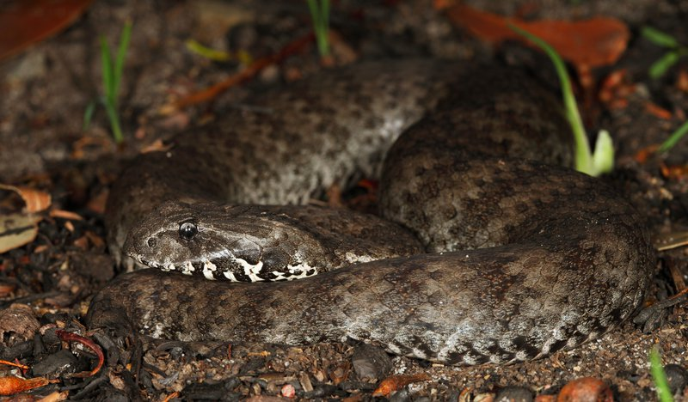
Death Adders are found in Northern Territory, Queensland, New South Wales, Victoria, South Australia and Western Australia.

DESCRIPTION:
It is easily recognised by:
- triangular-shaped head
- short stout body
- thin tail
- size ranges from 40-100 cm
- colour varies from grey to rich reddish-brown, usually with irregular dark crossbands and dark bars on the lips
1Common Death Adder
- underside is whitish with black or brown flecks, while the tail-tip is cream or black.
- have relatively large fangs and toxic venom which is fatal without medical aid in most cases.

BEHAVIOUR:
- an inactive snake
- spends much of its time lying concealed under loose sand, leaf litter or low foliage.
- may be active by day (diurnal) but is most commonly around at night (nocturnal) when moving between shelter sites.
- an ambush predator, waiting for prey to come to it rather than actively searching as do most Australian snakes.
- when lying in wait, the body is coiled with the tail tip near the mouth while the segmented tail tip is wriggled like a worm or caterpillar to lure prey.
- Individuals burrow into sand or leaf litter or hide under overhanging foliage.

HABITAT:
- found in a wide variety of well-drained habitats, including rainforests and wet sclerophyll forests, woodland, shrublands, grasslands and coastal heathlands,
- prefer habitats with lots of leaf litter.

FOOD:
- frogs, lizards, birds, and adults also eat small mammals
- quickly injects prey with venom and waits for it to die before eating.

BREEDING and YOUNG:
- mating usually occurs in spring.
- females reproduce only every second year.
- may give birth to up to 24 live young.
- Young are born in February or March

ADAPTATIONS:
- Camouflage - leaf litter, and bushes provide excellent concealment as the death adder’s markings and colour blend in well.
- Although a fairly inactive snake, it strikes rapidly - the fastest of any Australian snake.
- wriggly tail lures in rodents, lizards and birds who think the tail is a worm or caterpillar.
- Ambush hunting allows the snake to be safely concealed
- Its strong venom quickly kills prey
- Specialised organs call heat-sensing pits all ow the snake to detect nearby body heat of prey, even in darkness.

THREATS
- Road kills
- Eating toxic cane toads in northern areas of Queensland.
- Destruction and loss of habitat (clearing)
- Natural disasters such as fires
- Trampling by livestock
- Preyed upon by feral cats, foxes and pigs
- Deliberate killing of snakes
- Death from taking poisoned rodents

STATUS
- Considered rare in some places.
- Listed as vulnerable in the granite belt region.
- While it is a widespread snake, it is facing increased threat from the ongoing cane toad invasion. This is a concern. The cane toad eats the baby death adders while the adults eat the cane toad and are poisoned by the toxic glands on their skin.
- Although cane toads are not a problem in the Granite Belt, it is probable that they will be here eventually. They are a highly adaptable species.

References:
nhttps://australian.museum/learn/animals/reptiles/common-death-adder/

Online Zoological Collections of Australian

https://www.qld.gov.au/__data/assets/pdf_file/0029/67772/common-deathadder.pdf

https://bie.ala.org.au/species/https://biodiversity.org.au/afd/taxa/7c93bb6a-af83-445b-9740-a92a5cc752f0

