Native Vegetation of the Granite Belt Region
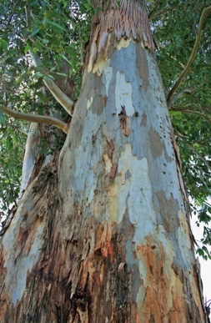
Native Trees
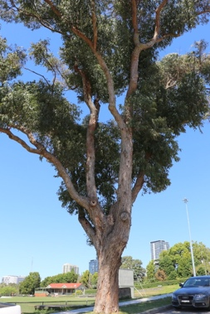
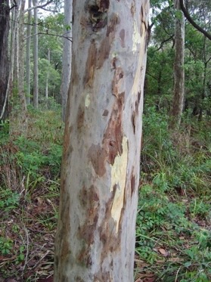
- Narrow-leaved ironbark
- Blue Gum
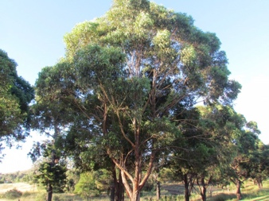
- Grey gum
- Spotted gum
- New England Blackbutt
- Tallowood
- Brush Box
- White mahogany
- Forest red gum
- Spotted gum
Tallowood
White mahogany
Spotted gum
Native Plants and flowers
Blue gum
- Golden wattle
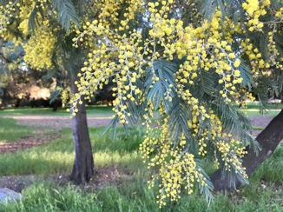
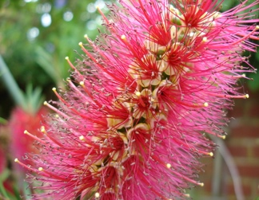
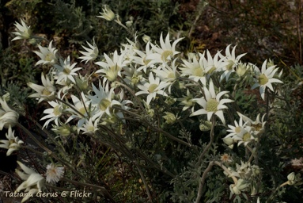
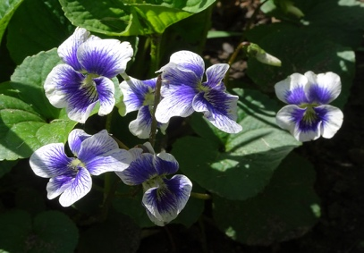
- Silver wattle
This Photo by Unknown Author is licensed under CC BY-NC-ND
This Photo by Unknown Author is licensed under CC BY-NC-ND
- Banksia
- Grevillea
- Bottlebrush
- Waratah
- Hovea
- Flannel flowers
- Christmas Bells
Bottlebrush
Silver wattle
Flannel flowers
Native violet
- Wallflower
- Heath myrtle
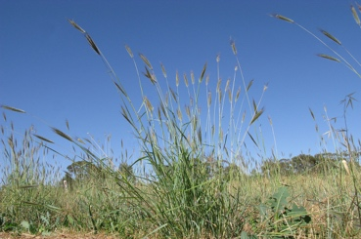
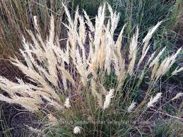
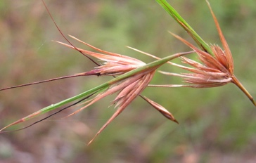
- Native violet
- Wallflower
- Christmas bells
- Pink bells
- Twisted wire vine
- Clustered everlasting
- Yellow buttons
Queensland blue grass
Wallaby grass
Kangaroo grass
Native Gasses
- Kangaroo grass
- Wallaby grass
- Queensland bluegrass
- Red grass

