Introduced Animals - Wild Dogs

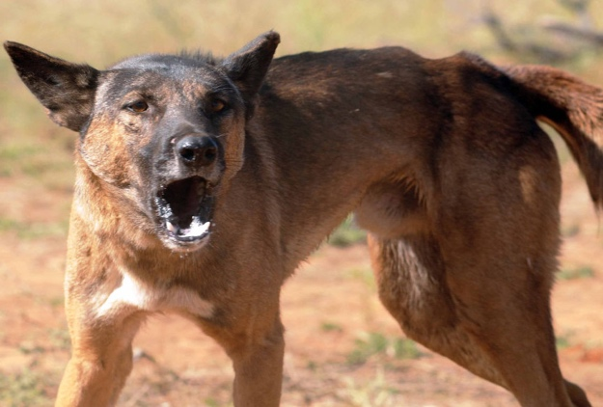
It is thought that dingoes arrived in Australia about 4000 years ago and domestic dogs arrived with Europeans from 1788 onwards.
This Photo by Unknown Author is licensed under CC BY

“Wild dogs” refers to both dingoes and feral domestic dogs because they have been interbreeding for so long.
However, pure dingoes are protected in protected areas such as National Parks.
Description:
- A top predator
- Can be any colour from white to black and everything in between.
- mostly short-haired
- Variety of sizes and weights
- Usually weigh between 11-24kg
- Have been known to weigh up to 60kg
- Often hard to distinguish between wild dog and dingo on external appearance alone.
Behaviour:
- generally, most active at dawn and dusk
- activity can occur day and night
- intense activity such as hunting
- exploratory activity involves moving over larger areas
- average distance covered per day is 15km
- take frequent short rests during day
- social animals, form packs at times to defend resources, feed, raise pups
- Howl. Dingoes cannot bark. Domestic feral dogs can do both.
Food:
- Use a range of hunting techniques.
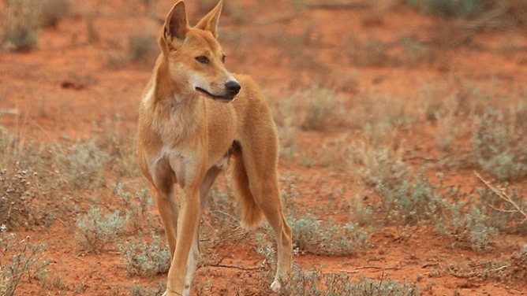
- Hunt individually and in packs
- Diet consists of kangaroo, wallaby, rodents, birds, brushtail possum, wombat, bandicoots, wallabies.

Habitat:
- Live in a range of habitats from deserts to alpine areas.
- Have adapted to urban habitats as well
- Mostly shelter in dens which can be enlarged rabbit warrens, wombat holes, logs, caves, rock ledges, grasses, debris
Breeding:
- Breeding occurs usually once a year, with an average of 5 pups a litter
- Two-thirds of pups usually die in the first year from disease or preyed on by foxes and eagles.
- Lifespan averages 5-7 years

Effects on wildlife and habitat
- They carry many different kinds of diseases that can be passed on to livestock and humans.
- Prey on livestock, injuring or killing them.
- They are a great threat to our endangered animals. Endangered species with small populations are more vulnerable to predation than larger populations which are more resilient.
- They will sometimes approach and attack people and pets.

https://agriculture.vic.gov.au/biosecurity/pest-animals/priority-pest-animals/wild-dog-dingodog-hybrids-feral-or-wild#:~:text=Most%20wild%20dogs%20are%20short,dingoes%20on%20external%20appearance%20alone.
Government of Victoria: Department of Agriculture. Wild dogs

