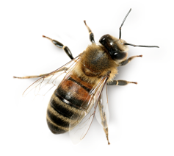
This Photo by Unknown Author is licensed under CC BY-NC
FACT OR OPINION?
Bees are winged insects. F O The platypus is an excellent swimmer. F O

Bees produce honey. F O I think a platypus would be a good pet. F O

Bees are the scariest insects of all. F O The platypus is the cutest animal in the world. F O

All worker bees are female. F O The platypus is a marsupial. F O

I think that bees sting when they are angry. F O The platypus can hunt for food underwater. F O

What is your opinion about bees? What is your opinion about the platypus?
.................................................................................................... ..................................................................................................................

.................................................................................................... ..................................................................................................................

.................................................................................................... ..................................................................................................................
Find and write 1 more fact about bees. Find and write 1 more fact about the platypus.
.................................................................................................... ..................................................................................................................

.................................................................................................... ..................................................................................................................

.................................................................................................... ..................................................................................................................
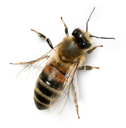
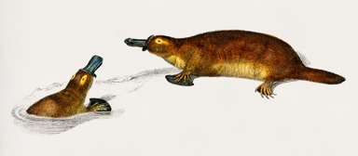
This Photo by Unknown Author is licensed under CC BY-NC
